# 

# **We Serve**

   
 

**Documentation**

**Admin Manual**

**Table of Contents**

1. Introduction……………………………………………………………………………..…3
2. Setting up the Environment……………………………………………………………….3
3. Downloading from Github…………………………………………………..………….....5
4. Steps to run the WeServe User application………………………………………….…….6
5. Steps to run the WeServe Admin application…………………………………………..…9
6. Registering as an Administrator…………………...…………………………....………..12

Appendix A: Record of Changes………………………………………………………...17

Appendix B: Glossary…………………………………………………………………....18

**1 INTRODUCTION**

“WeServe” is an application that provides small-scale businesses a platform to sell their services and products to customers. In essence, “WeServe” is an e-commerce site similar to Etsy or Amazon but is capable of providing much more than just products. “WeServe” will act as the middleman, allowing customers to purchase local products through vendors on “WeServe”. WeServe also verifies the license of vendors before registering them on our application. This documentation is going to guide the users through the various processes that take place in the WeServe application and how to go through the tasks.

**2 SETTING UP THE ENVIRONMENT**

In order to run this application on the system, the admin will require the following softwares:

1. Node.js: In order to install node.js, you can go to the following link.

<https://nodejs.org/en/download/>

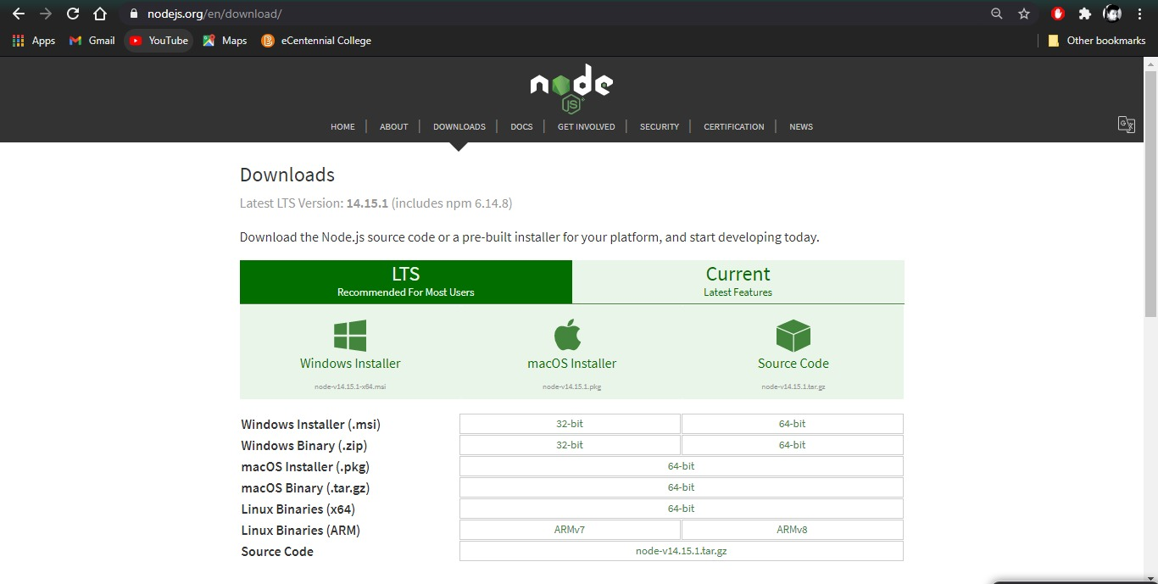

Download as per the requirements of your system and install through the following the instructions from the download website.

1. MongoDB: In order to install mongodb, go to the following link.

<https://www.mongodb.com/try/download/community>

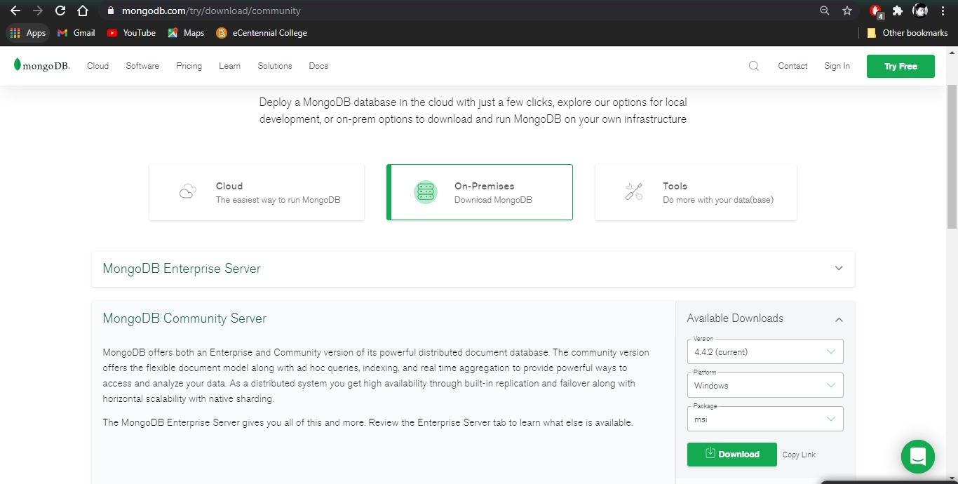

Download as per the requirements of your system and install through the following the instructions from the download website.

1. Account Creation in Cloudinary

For the next step, create an account in Cloudinary through the following link.

<https://cloudinary.com/>

Cloudinary is a media API for Mobile Apps and websites. After signing in, your profile will be like the image above. Note down the API Key, cloud name and Api secret. You will require it in the application.

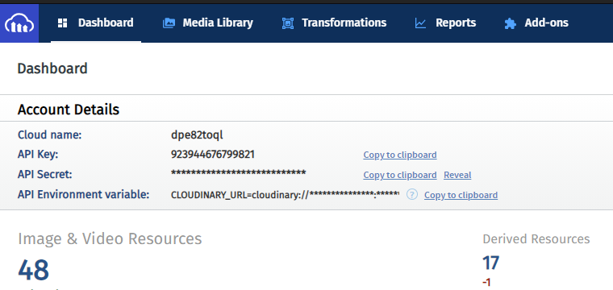

**3 DOWNLOADING FROM GITHUB**

To download this application, please go to this link:

<https://github.com/comp231-S5G1/WeServe/tree/WeServe-Final>

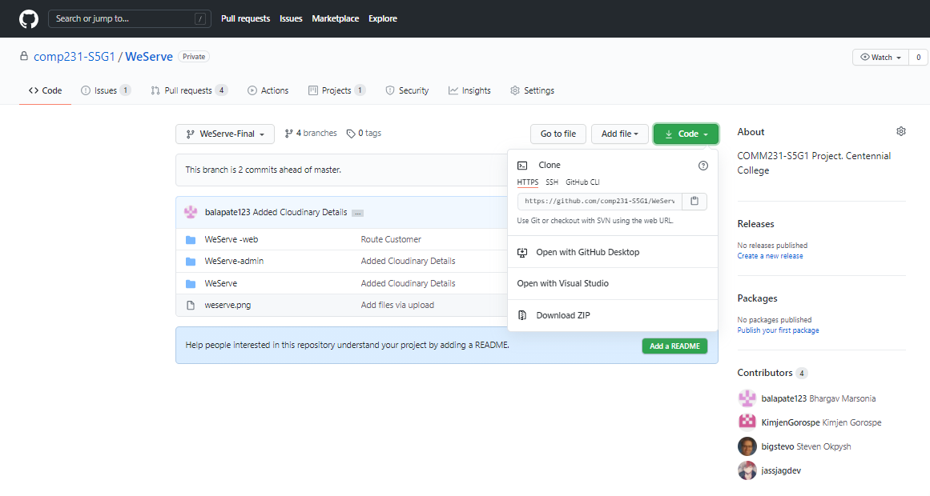

Changing the .env file with your cloudinary information. When you create a cloudinary account, you will get the cloud name, API key and API secret. Open the .env file on both folders, ‘We Serve’ and ‘WeServe-admin’ and replace the details there.

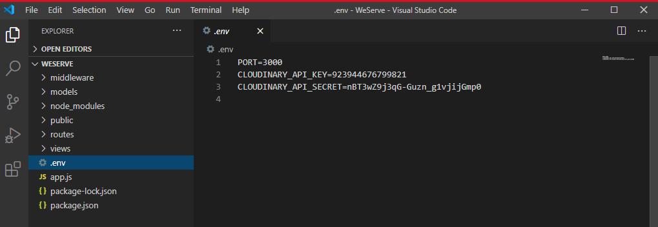

**4 STEPS TO RUN THE WESERVE USER APPLICATION**

Step 1: Click on the code button and then click on download zip. Then unzip the file in your computer.

Step 2: Open command prompt. Write the following command:

mongod --dbpath="Destination where you want the database to be"

For example : mongod --dbpath="C:\Users\MyComputer"

Let the command prompt remain active. This will initialize mongoDB in your system.

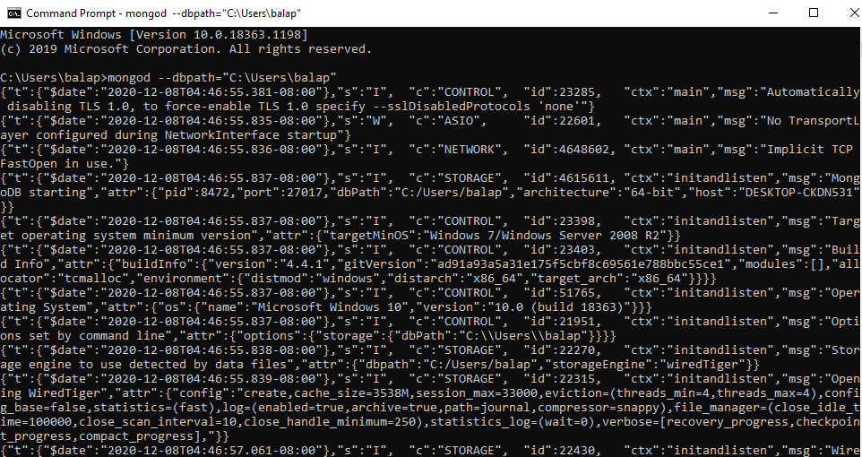

Step 3: Open another command prompt. Type the following command and press enter:

mongo

This will start mongo in your system.

Step 4: Then, type the following command and press enter:

use weserve

This will initialize and create the WeServe Database in your system.

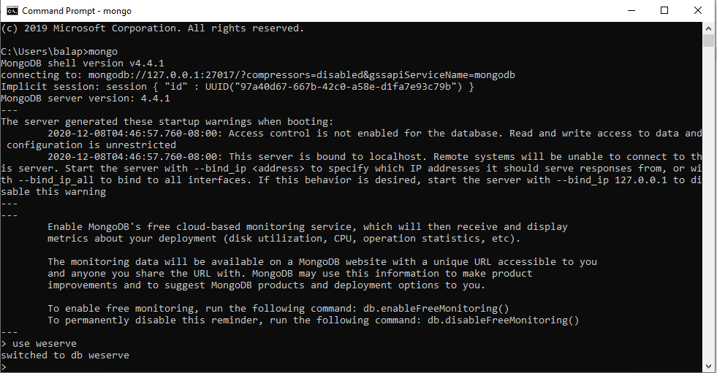

Step 5: Open the folder where you unzipped the ‘WeServe-Final’ repository in the computer. Open the ‘We Serve’ folder inside that folder and open that folder in Command Prompt. Type the following code:

npm install

This will download the required libraries and dependencies for the application.

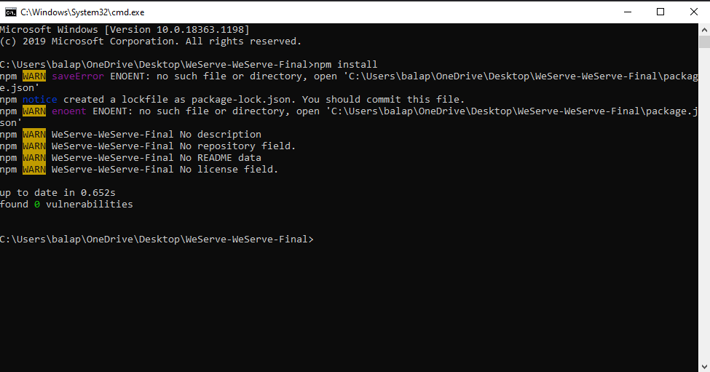

Step 6: Type the following command:

npm start

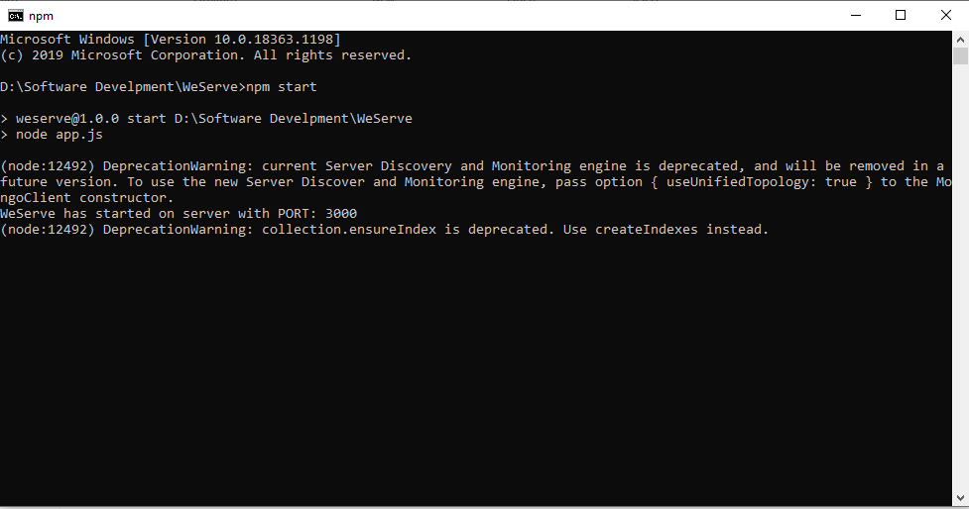

Now, the application will start running on localhost:3000

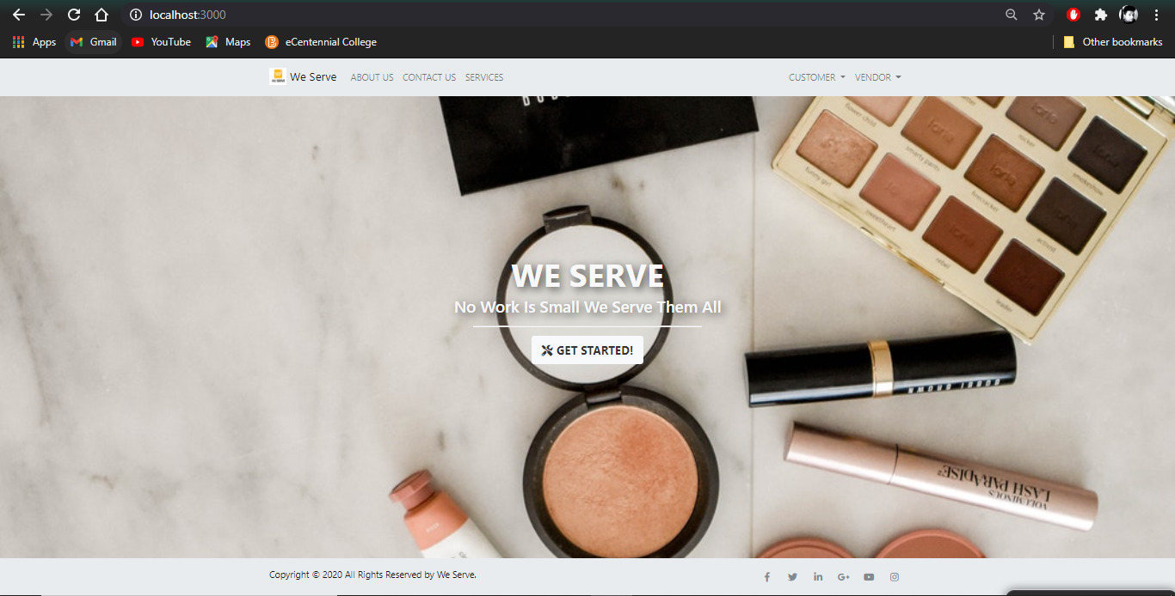

**5 STEPS TO RUN THE WESERVE ADMIN APPLICATION**

Step 1: If your MongoDB database is active then go to Step 5.

Step 2: Open command prompt. Write the following command:

mongod --dbpath="Destination where you want the database to be"

For example : mongod --dbpath="C:\Users\MyComputer"

Let the command prompt remain active.



Step 3: Open another command prompt. Type the following command and press enter:

mongo

Step 4: Then, type the following command and press enter:

use weserve



Step 5: Open the folder where you unzipped the ‘WeServe-Final’ repository in the computer. Open the ‘WeServe-admin’ folder inside that folder and open that folder in Command Prompt. Type the following code:

npm install

This will download the required libraries and dependencies for the application.



Step 6: Type the following command:

npm start

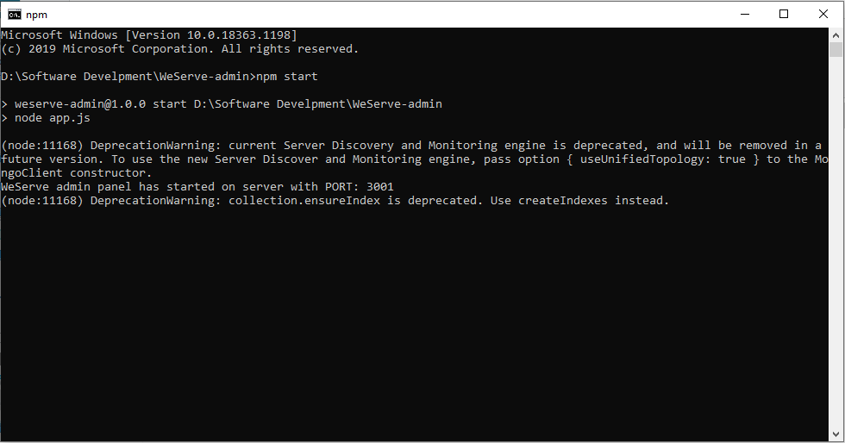

Now, the admin application will start running on localhost:3001

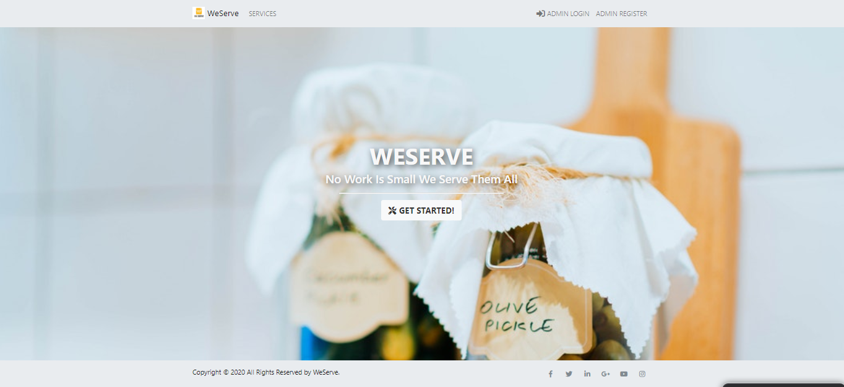

**6 REGISTERING AS AN ADMINISTRATOR**

Step 1: Open the admin web application.  
Step 2: Register as an admin.

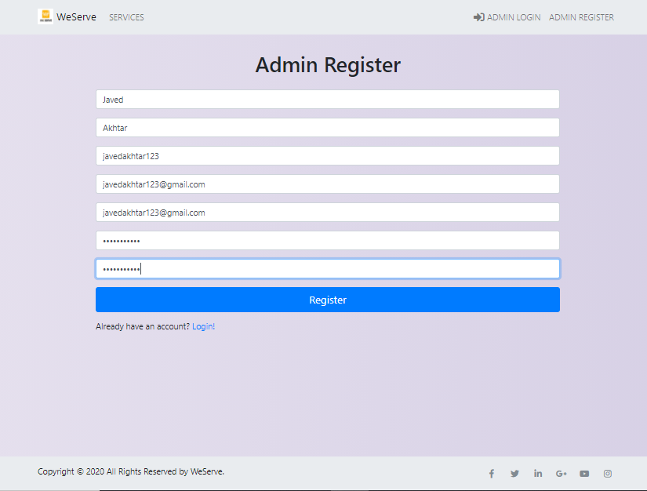

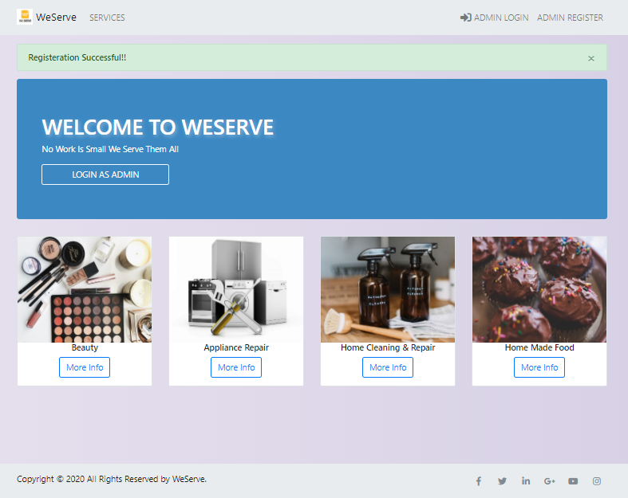

Step 3: Log in into the system.

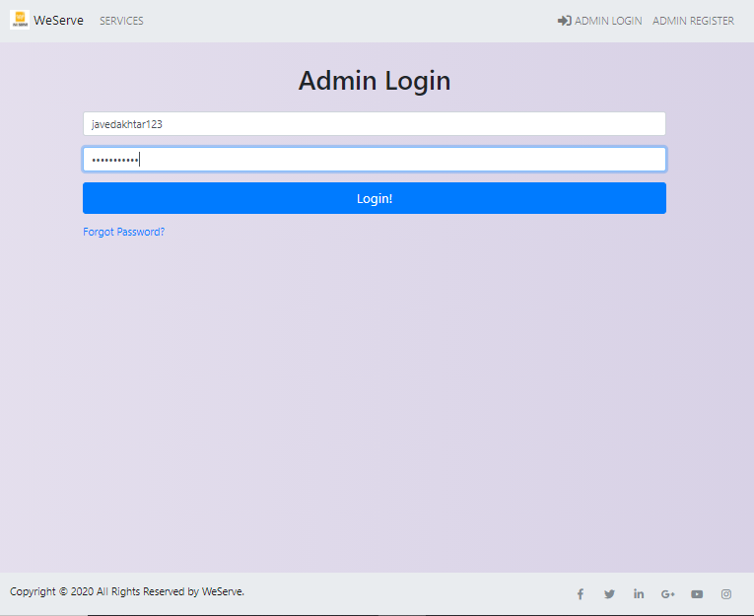

Step 4: Click on Vendor Request

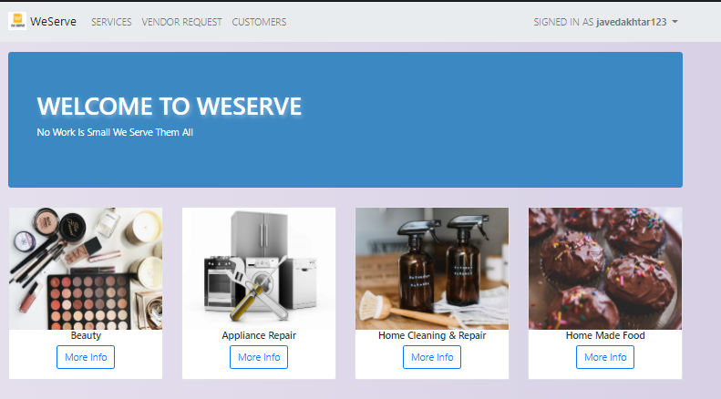

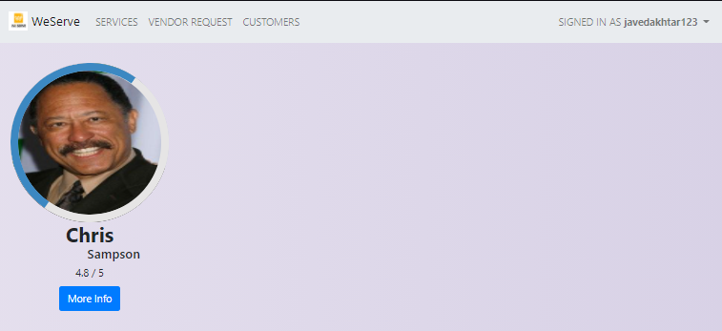

Step 5: Accept/Decline vendor request:

Click on more info and you will be prompted to the vendor profile.

Accept or decline as per your preferences.

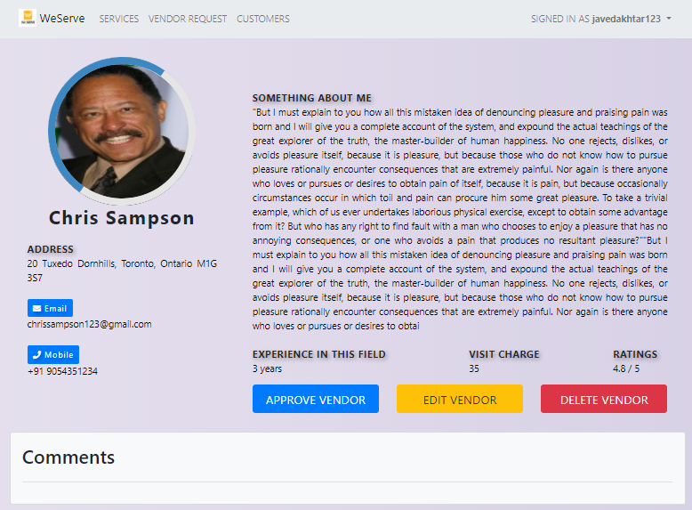

Step 6 : Handling Customers:

To handle customers, click on ‘CUSTOMERS’ on the home screen.

You will be prompted to the following screen.

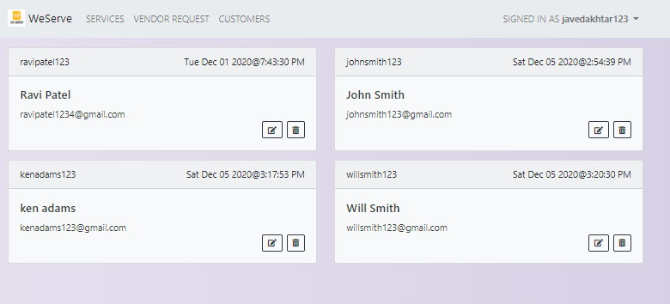

You can edit and delete customers from here.

Step 7: Handling Vendor:

To handle Vendors, click on to ‘Services’ on the home screen. Select the service where the vendor is you are looking for and open his profile. You can edit and delete vendor from here.

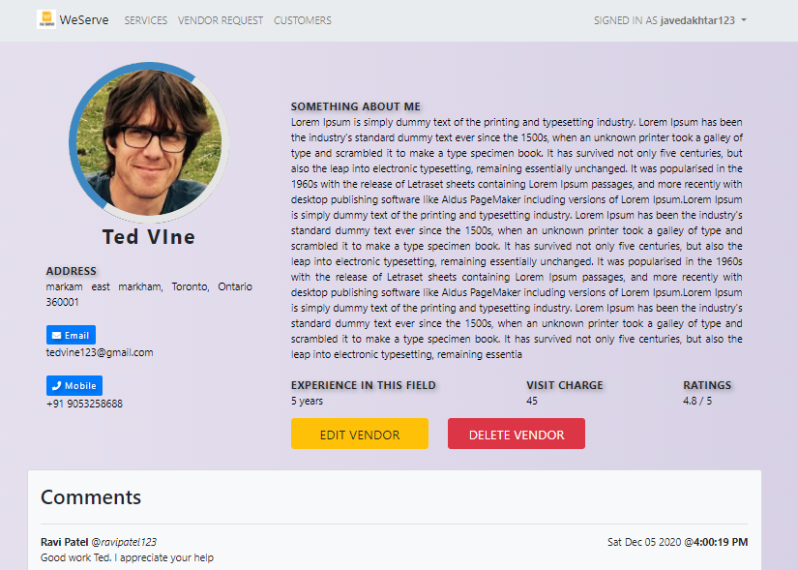

**Appendix A: Record of Changes**

|  |  |  |  |
| --- | --- | --- | --- |
| **Version Number** | **Date** | **Author/ Owner** | **Description of Change** |
| 1.0 | November 19, 2020 | Bhargav Marsonia | Initial Draft |
| 1.1 | December 7, 2020 | Bhargav Marsonia | Final Draft |
|  |  |  |  |

**Appendix B: Glossary**

|  |  |
| --- | --- |
| **Term** | **Definition** |
| Admin | An Administrator provides office support to either an individual or team and is vital for the smooth-running of a business. |
| Vendor | In a supply chain, a vendor, or a seller, is an enterprise that contributes goods or services. Generally, a supply chain vendor manufactures inventory/stock items and sells them to the next link in the chain. |
| Customer | In sales, commerce and economics, a customer is the recipient of a good, service, product or an idea - obtained from a seller, vendor, or supplier via a financial transaction or exchange for money or some other valuable consideration. |